NAME: ADARSH P NAYAK
CLASS: CSE AIML B
DATE: 23 FEB 2026
LAB: 7
REG NO: 240962518

1. Modify the above Producer-Consumer program so that, a producer can produce at the most 10 items more than what the consumer has consumed.

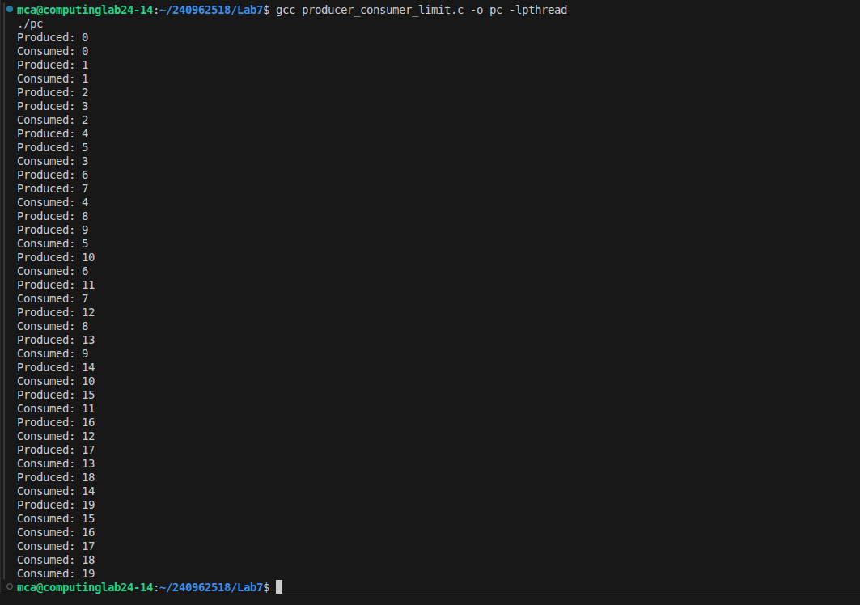

2. Write a C/C++ program for first readers-writers problem using semaphores.

